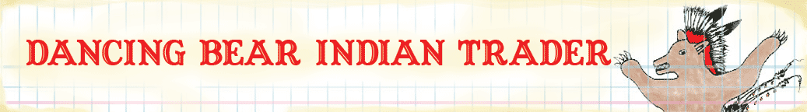
Directions for the Dancing Bear Indian Trader Quilt©.

Supplies needed:
1 FQ of Red Tipis  1 FQ of Black Tipis  1 FQ of Beige Running Horses  1 FQ of Black Running Horses  Batting  Red Thread  Turquoise Thread  Red Acrylic Paint | Blue Acrylic Paint  Yellow Acrylic Paint  Small thin paint brush  Sewing Machine  Rotary Cutter or Scissors  Cutting board  Pins  Safety Pins

Directions:

Press both Horse fabrics so that they are not creased.
Use a paper plate as a palette, and small thin brush.
Water down the acrylic so that it is a bit thinner than the original consistency (not dripping, think of it as an ink). You want to have it just right so that you can use the paint to soak in a bit. Practice on scrap material before using the Horse fabric.

Cut the Red and Black Tipis in 4 long pieces 4.5” x 22” with a Rotary Cutter or Scissors
Pair the Red Tipis with the Black Horses and Black Tipis with the Beige Horses.
Make sure to pay attention to the orientation of the designs.
Pin one strip to the top and bottom of each piece of the horses FQs. Right sides together.
Sew ¼” seam along the top and bottom of each horse fabric piece.
Press the seams towards the center.
Pin strips to both sides of the horse fabric pieces.
Pair the Red Tipis with the Black Horses and Black Tipis with the Beige Horses.
There will be an extra amount on these lengths, make sure to allow for the selvage to be trimmed.
Make sure to pay attention to the orientation of the designs.
Sew ¼” seam along the sides of each horse fabric piece.
Press the seams towards the center.

You have your two pieces.
Pin the seams down, and use a decorative stitch to go along the edge of the Tipi border of each piece, using a contrasting color for the thread. We used a decorative triangle stitch with turquoise colored embroidery thread.

Cut a piece of batting for each completed mini horse quilt.
Center horse fabric piece, with tipis on batting and use safety pins to attach in several places starting from the center and working out. About every 3”-4” place a pin.

Decorative quilting:
Outline horses with red thread.
Circles in the background with red thread.

If your machine has a free-motion feature, it works great for this design.
Drop feed dog in sewing machine and stitch moving the fabric around with your hands outlining the horses, or making circles in the background.

